Volitive Interjections

🔹 What Are Volitive Interjections?
# Source: AI Source: Provided by: [Data Path: Persons Table -> ID Column: 1, Name_En Column: Motasem Essam] -> From: [Chatgpt (GPT-4-turbo)] on [7/28/2025]
Volitive interjections are words or phrases used to express a strong desire, wish, command, or request.
They are often used to get someone's attention or to influence someone's behavior.

✅ Key Features
# Source: AI Source: Provided by: [Data Path: Persons Table -> ID Column: 1, Name_En Column: Motasem Essam] -> From: [Chatgpt (GPT-4-turbo)] on [7/28/2025]
- Show intent or will (volition = will)
- Often used in commands, warnings, or requests
- Common in spoken language and direct communication
- Usually followed by an exclamation mark (!) or a pause

🧩 Common Volitive Interjections
# Source: AI Source: Provided by: [Data Path: Persons Table -> ID Column: 1, Name_En Column: Motasem Essam] -> From: [Chatgpt (GPT-4-turbo)] on [7/28/2025]
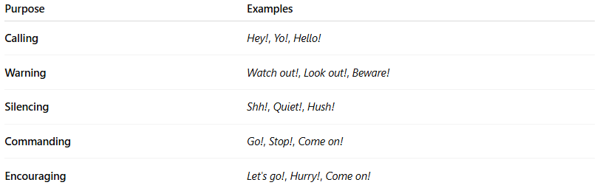
Purpose | Examples
Calling | Hey!, Yo!, Hello!
Warning | Watch out!, Look out!, Beware!
Silencing | Shh!, Quiet!, Hush!
Commanding | Go!, Stop!, Come on!
Encouraging | Let's go!, Hurry!, Come on!

📚 Example Sentences
# Source: AI Source: Provided by: [Data Path: Persons Table -> ID Column: 1, Name_En Column: Motasem Essam] -> From: [Chatgpt (GPT-4-turbo)] on [7/28/2025]
- Hey! Wait for me! (calling attention)
- Shh! The baby is sleeping. (silencing)
- Watch out! There’s a car coming! (warning)
- Go! Don’t miss your chance! (command)
- Come on! You can do it! (encouragement)

